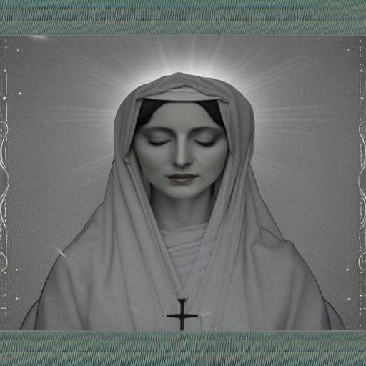
SAMSARA MAYA

She was incomparable
She was an unrequited lover in the flesh - a Holy Thing
She became Daena, leading to the Immaculate Conception

And She was Perfectly Everything - Samsara Maya - the final illusion - the narrow gate of Truth

A shining door and The Woman with the Singular Touch

